HOW TO APPLY “EGOSUM” BRACELET

Warning! The strict and precise procedures of drawing up and assembly of the identifying cards in their relative location guarantee a correct identification. In our packaging you will find anything you need to apply our identification system. The “Risk Management” red circle can be applied by following the figures step by step. This is an easy procedure to be followed and provided that it is respected, it gives you the certainty of a non-removable identification.
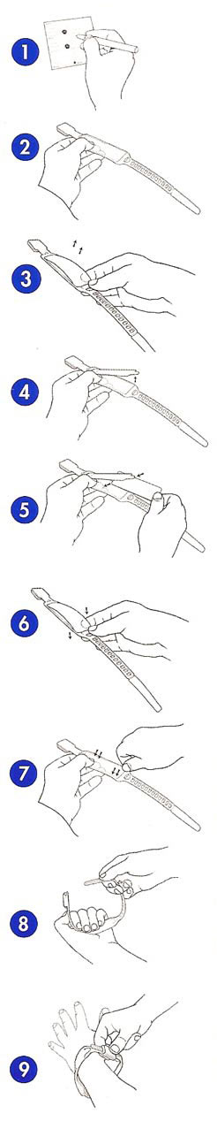
Separate the 5 cards showing the same progressive number from
the continuous paper along the transversal cross-hatching. Fill in the
gaps with all data obtained by following the advice in the warning.
Tear the bigger card out by following the cross-hatching, then put it
directly into the bracelet. The four smaller ones are adhesive, they
can be removed and stick again on the medical record or wherever
traceability is necessary.

Take the bracelet reversed.

Take off the foil just on one side lifting it up.

Lift the foil up just as much suffices for inserting the card inside

Insert the bigger card between the foil and the bracelet with the
printing and writings downwards facing.

Position again the foil the same way it was before.

Do the operation above very carefully since a correct reassembly
makes the card zone waterproof. Therefore make adhere the foil to
the bracelet by applying pressure on the perimeter border of the foil
particularly on the angles of the short sides.

Set the bracelet into a circle by pressing the foil along the bracelet
so that it will adhere perfectly.

Now fasten the bracelet to the patient’s wrist without tightening it too
much since the fastener is irreversible and it is impossible to widen it
again.

